

**Dynamics 365 – Configure to order**

**Revision 1**

**Revision History**

|  |  |  |  |  |
| --- | --- | --- | --- | --- |
| **Date** | **Revision** | **Description** | **Signature / Date** | |
| 08/12/2022 | 1 | Initial draft of user manual: Configure to Order | Prepared | Waseem Abbas |
|  |  | Verified |  |
|  |  | Approved |  |
|  |  |  | Prepared |  |
|  |  | Verified |  |
|  |  | Approved |  |
|  |  |  | Prepared |  |
|  |  |  |  |
|  |  |  |  |
|  |  |  |  |  |
|  |  |  |  |
|  |  |  |  |

**Table of Contents**

1 About User Manual 5

2 Dynamics 365 – Smart Wires Products 5

2.1 SW Customer Projects 5

2.2 SW Products Assemblies 6

2.3 All Smart Wires Products 6

2.4 All products Features 8

2.5 All product Package 10

2.6 All Assemblies Selection 13

2.7 All projects 14

2.8 All Customer 15

2.9 All Customer Projects 16

2.10 Import Project 18

2.11 Import Project Package 19

3 Work Instruction Document 21

List of Figures

Figure 1 Smart Wires Products 6

Figure 2 Open the Trade agreement 6

Figure 3. SW product Assemblies 7

Figure 4. All Smart Wires products 7

Figure 5 All Smart Wires Product Description Already Exist 8

Figure 6 All Smart Wires Record already Exist 8

Figure 7 All Smart Wires Products Record Added Successfully 9

Figure 8 All products Features 9

Figure 9 Feature short Name can't be Empty 10

Figure 10 All product Features Record Already Exist 10

Figure 11 All Product Features Record Added Successfully 11

Figure 12 SW product Package 11

Figure 13 All Product Feature Package cannot be empty 12

Figure 14 All Product Features Feature not Selected 12

Figure 15 All Product Packages Added Successfully 13

Figure 16. All Assemblies selection 14

Figure 17. All Assemblies selections Configured Already Exist 14

Figure 18 All Assemblies Selection Record Added Successfully 15

Figure 19. All Projects 15

Figure 20 All projects Pop up 16

Figure 21 All Customer 16

Figure 22 Custoemr Group field is Necessary 17

Figure 23 All Customers Projects 17

Figure 24 Press Add button to add Customer Project 18

Figure 25 Duplicate Record Alert 18

Figure 26 Import Project 19

Figure 27 Browse file to import it 19

Figure 28 Message after importing the file 20

Figure 29 Import Project Package 20

Figure 30 Browse file to import it 21

Figure 31 Message after importing the file 21

Figure 32 Data Management on Dashboard 22

Figure 33 Click on Work Instruction Document 22

Figure 34 Confirmation popup to import the Work Instruction Document 23

Figure 35 Upload the import Work Instruction Document 24

Figure 36 Confirmation Alert on Already Exist file i the item 24

Figure 37 Success Message to after importing the Work instruction Document 25

Figure 38 Zip file with included Documents 25

Figure 39 Data Sheet with the Same Name of file in the Zip 26

Figure 40 Release Product Variant to View the Products 26

Figure 41 Select Item and Click on I After Selecting the Items 27

Figure 42 View and Download the selected File by clicking on open 27

# About User Manual

In this manual, it will be briefed about configure the order flow. The configure to order give information about the project, Customer, Packages, Features and product creation and view.

# Dynamics 365 – Smart Wires Products

In order to create a new vendor, select the modules option. Go to the Procurement and Sourcing and select ‘All vendors’ available under the Vendor sub-option.

Navigation: Product Information and Management > Smart Wires Products > SW Customer Projects, SW Product Assemblies, All Smart Wires Product, All product Packages, All products Features, All Assemblies Selections, All projects, All Customers All Customers Projects.

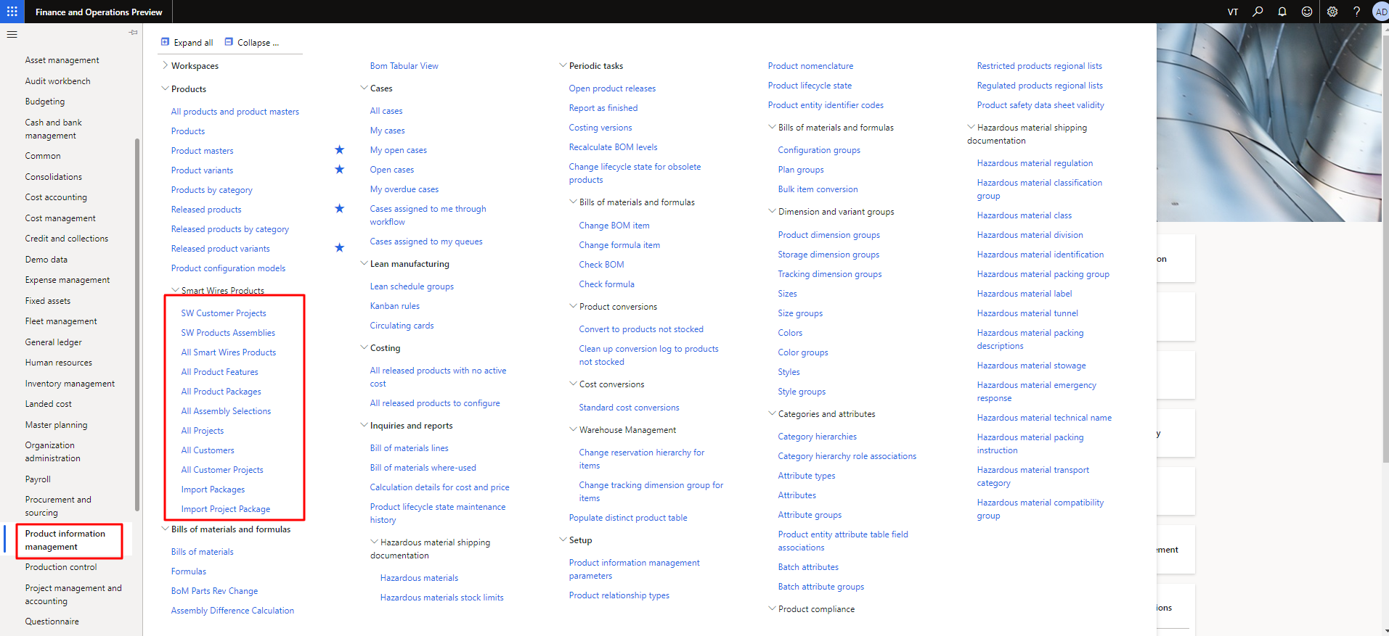

Figure 1 Smart Wires Products

## SW Customer Projects

The user can see the Smart Wires customer project in this module. The user can also apply the filter to find any specific project in the list.

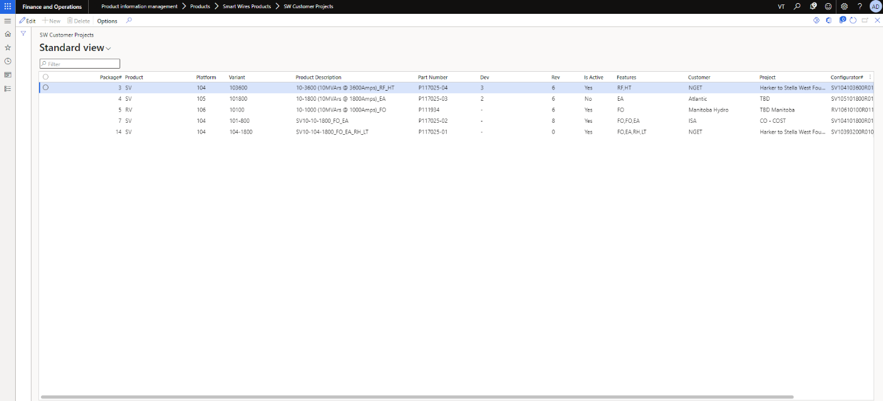

Figure 2 Open the Trade agreement

## SW Products Assemblies

The user will be able to see the products Assemblies with their information. The user can also apply the filter to find the any specific assembly in the list.

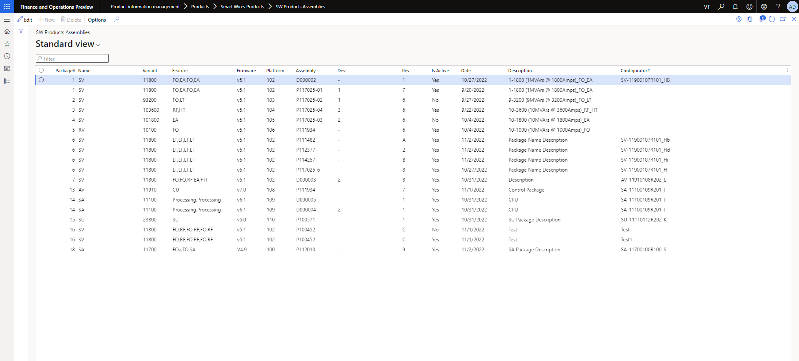

Figure 3. SW product Assemblies

## All Smart Wires Products

The user can see and add new Smart Wires products in this module.

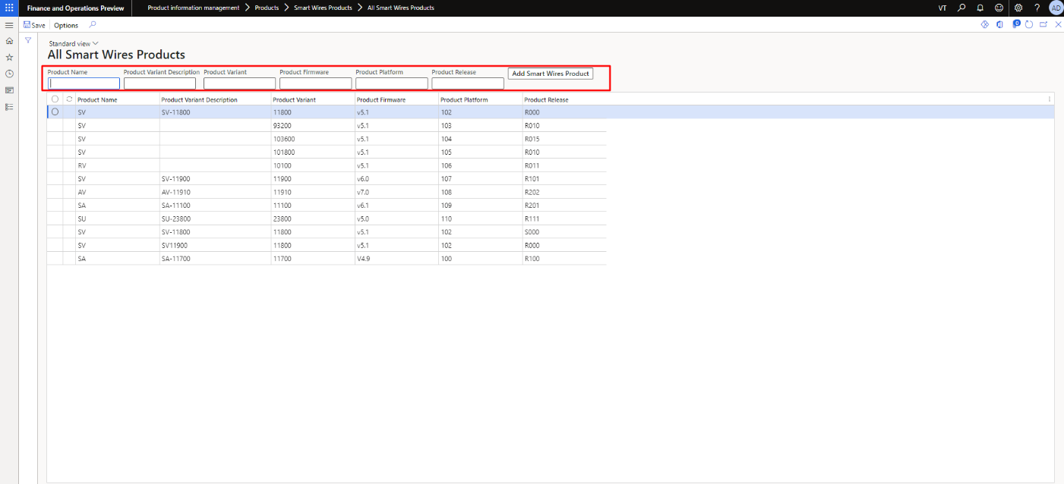

Figure 4. All Smart Wires products

The user can’t add the duplicate Product Variant Description while adding the Smart Wires product.

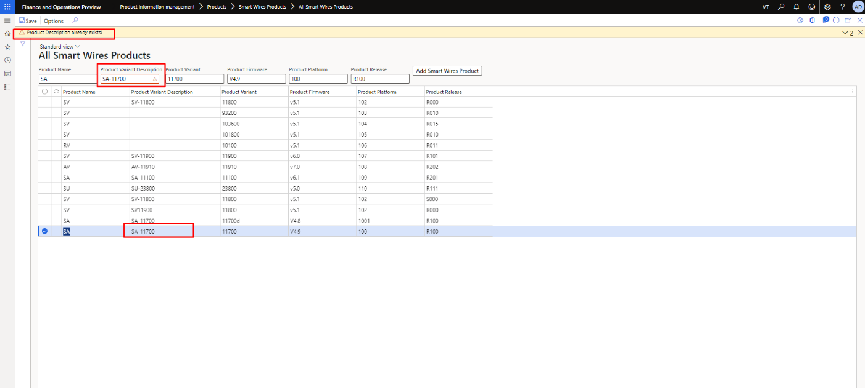

Figure 5 All Smart Wires Product Description Already Exist

The user can’t add the duplicate record in the list.

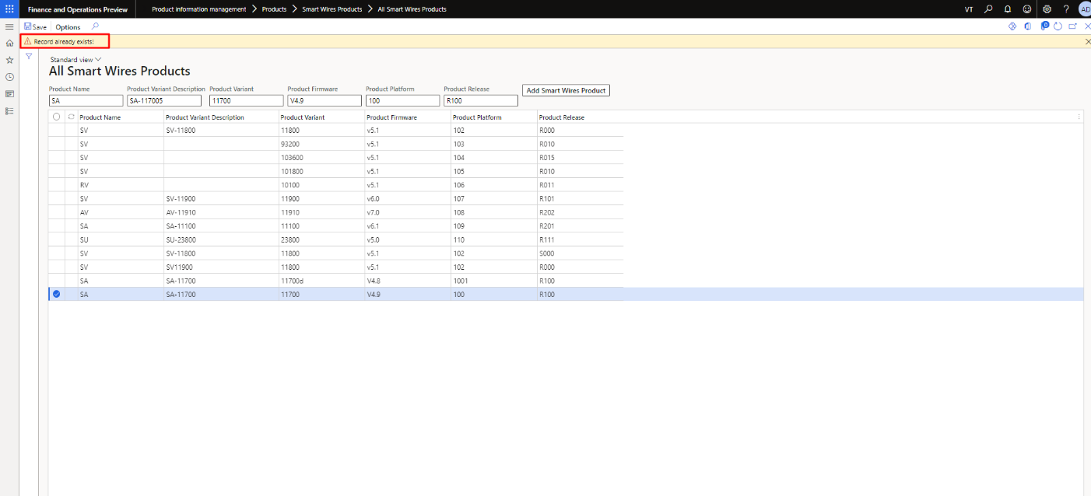

Figure 6 All Smart Wires Record already Exist

The user will receive the success message after adding all the fields currectly.

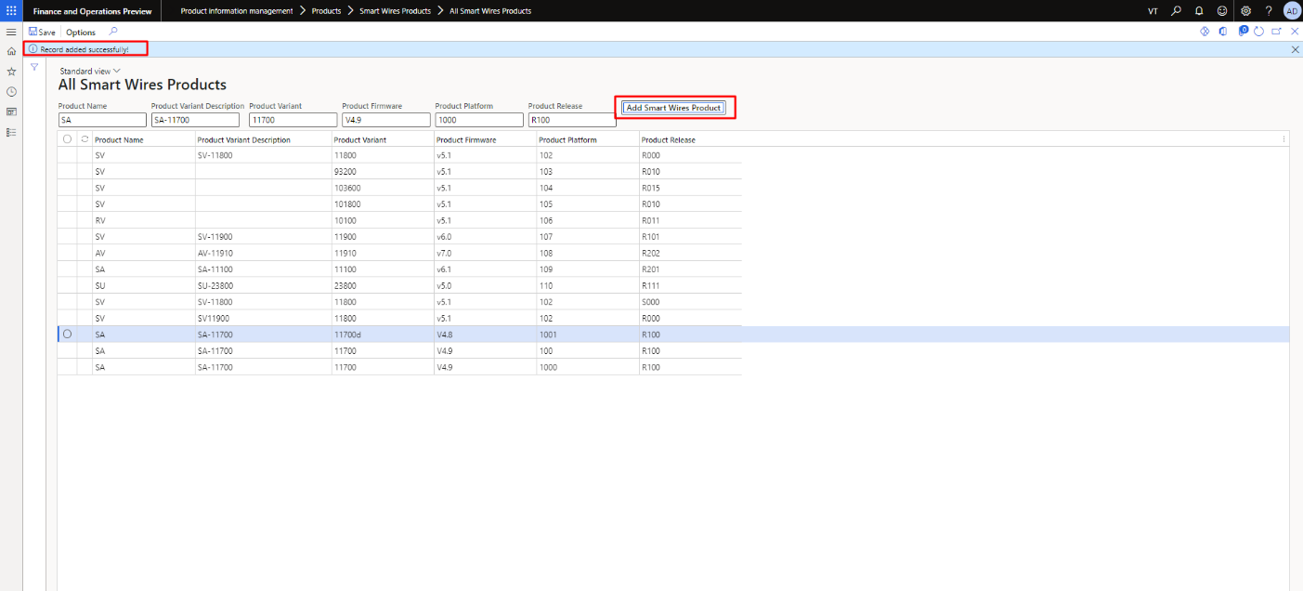

Figure 7 All Smart Wires Products Record Added Successfully

## All products Features

The user can see and add new products feature in the list.

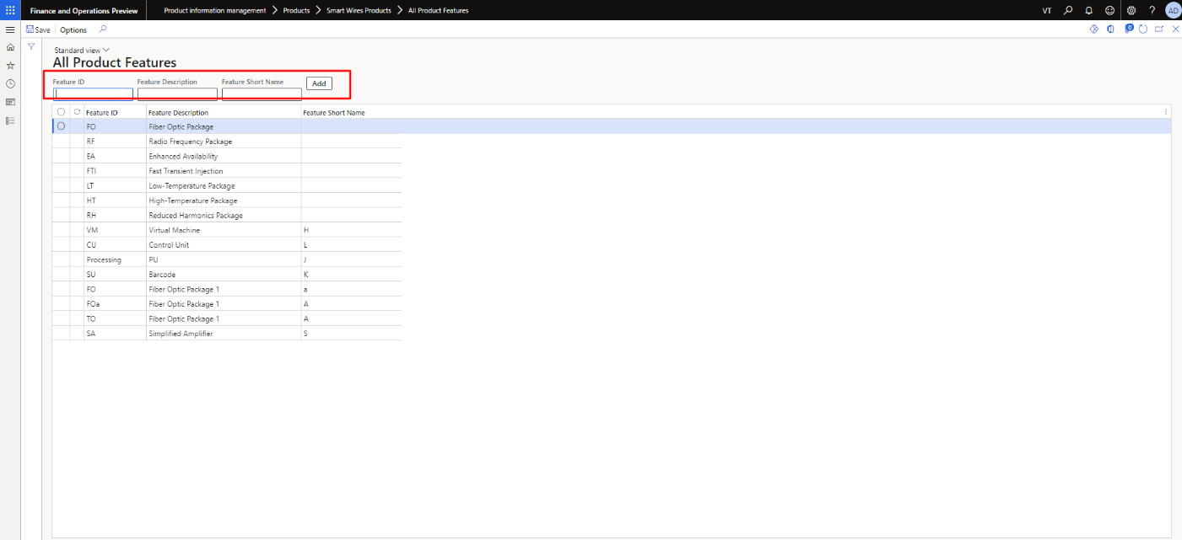

Figure 8 All products Features

The user can’t add the new product feature without Feature Short Name.

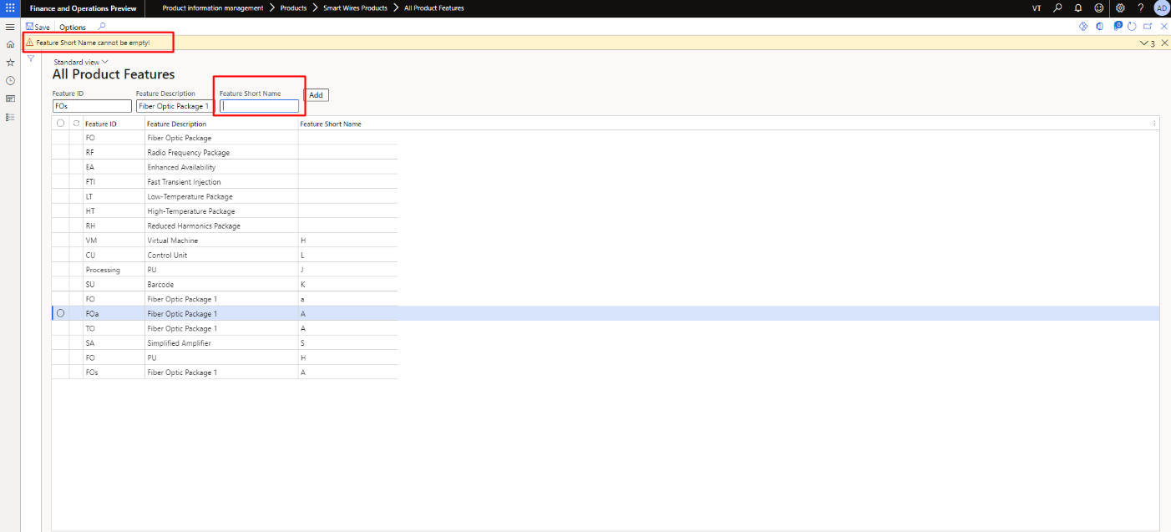

Figure 9 Feature short Name can't be Empty

The user can’t the add the duplicate record in the list.

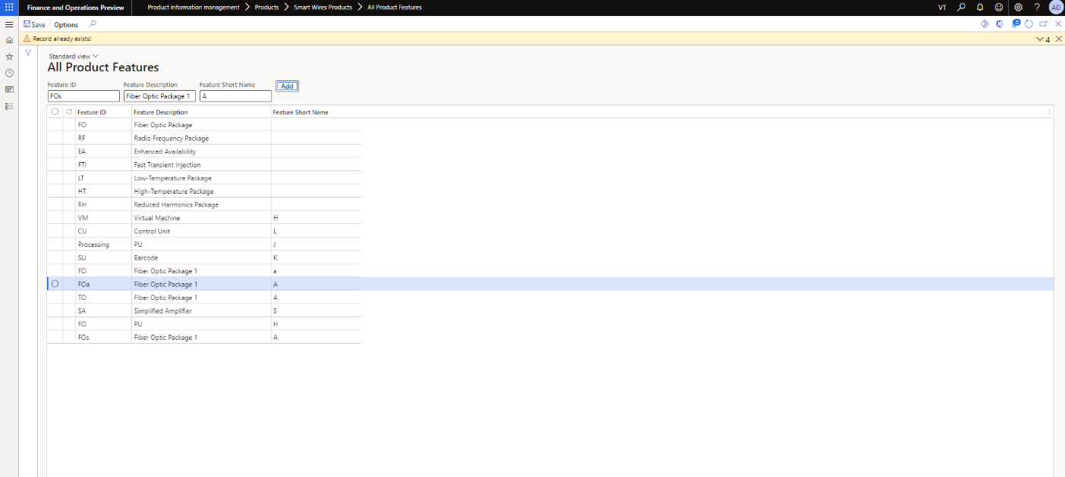

Figure 10 All product Features Record Already Exist

The user will receive the success message after adding all the fields correctly.

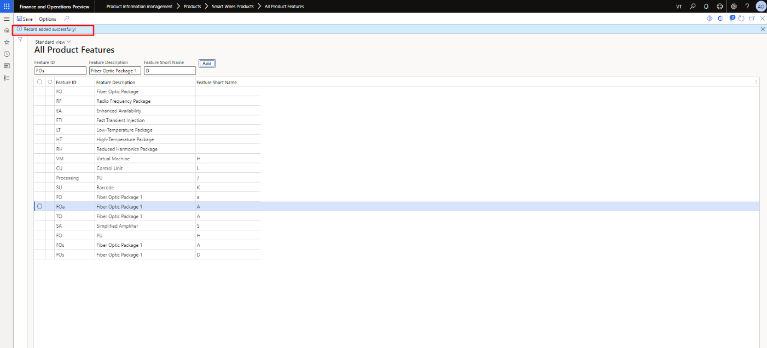

Figure 11 All Product Features Record Added Successfully

## All product Package

The user can see and add new products package in the list.

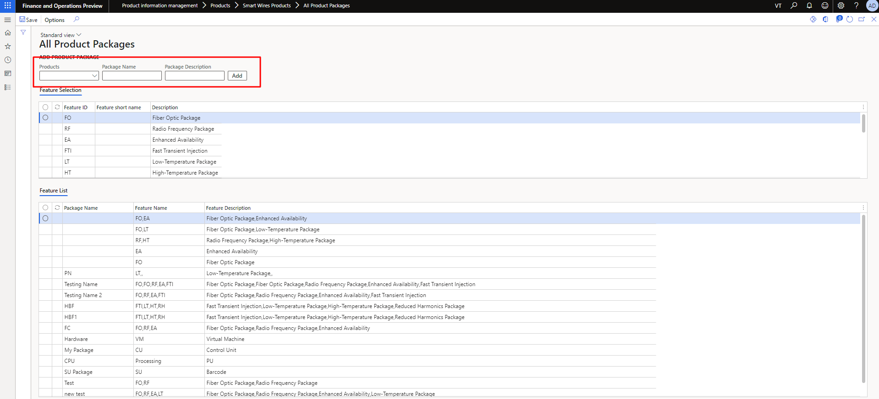

Figure 12 SW product Package

The user can’t add the new product package without Package Name.

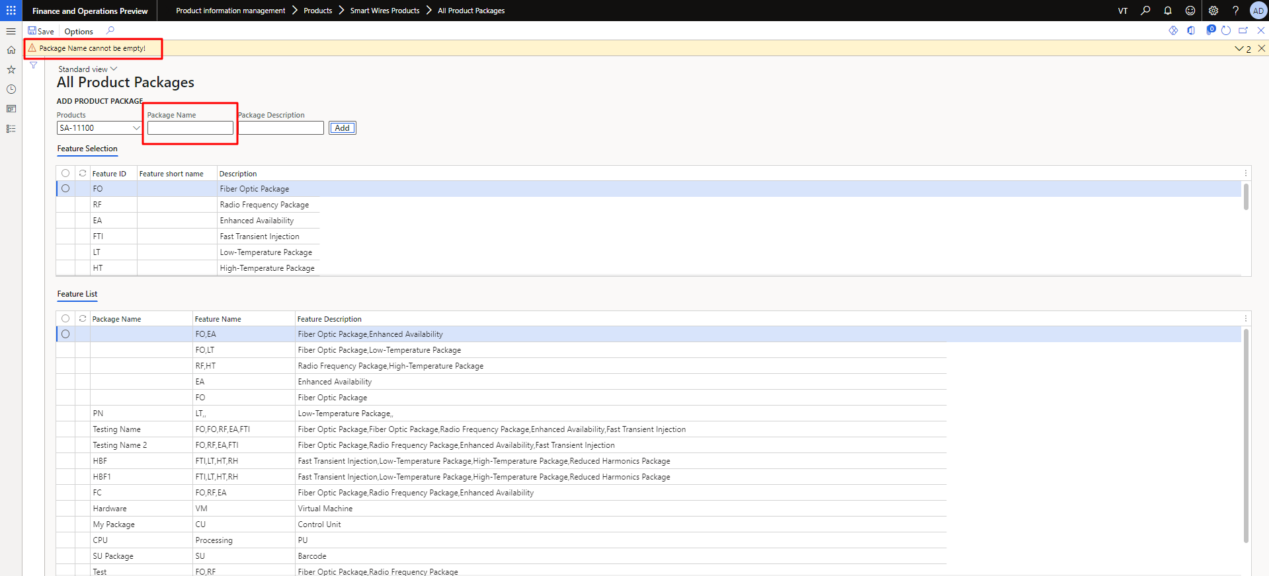

Figure 13 All Product Feature Package cannot be empty

The user can’t add the new product package without Feature Selection.

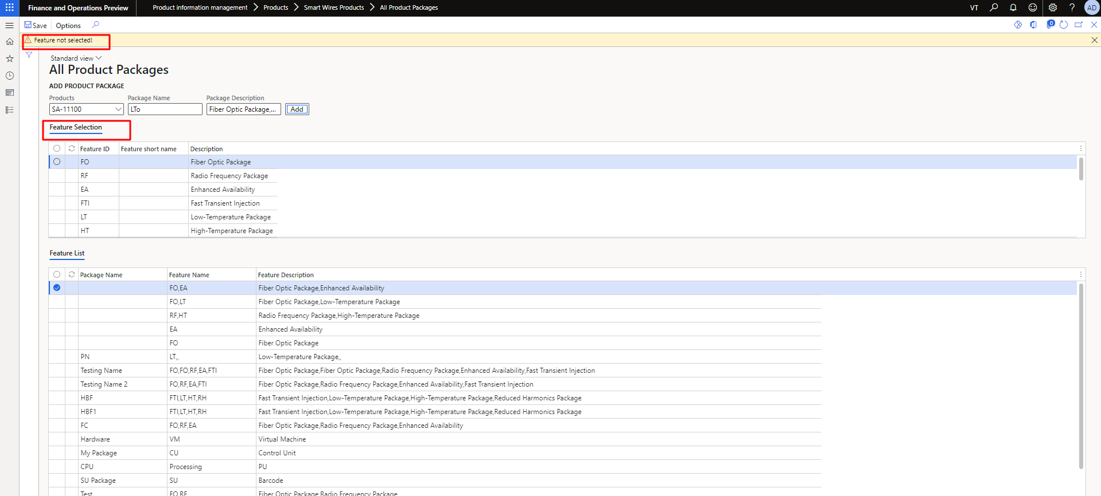

Figure 14 All Product Features Feature not Selected

The user will receive the success message after adding all the fields correctly.

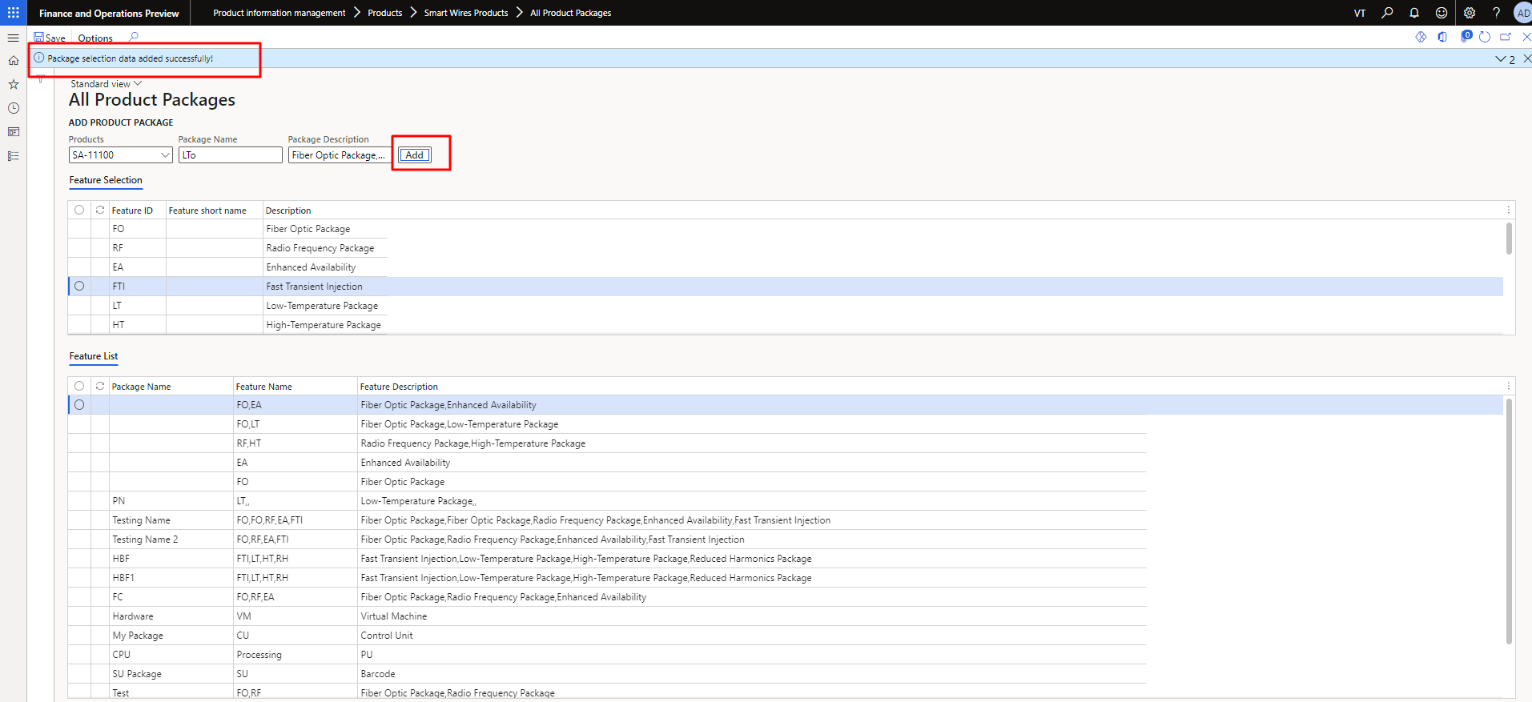

Figure 15 All Product Packages Added Successfully

## All Assemblies Selection

The user can see and add new Assemblies Selection in the list.

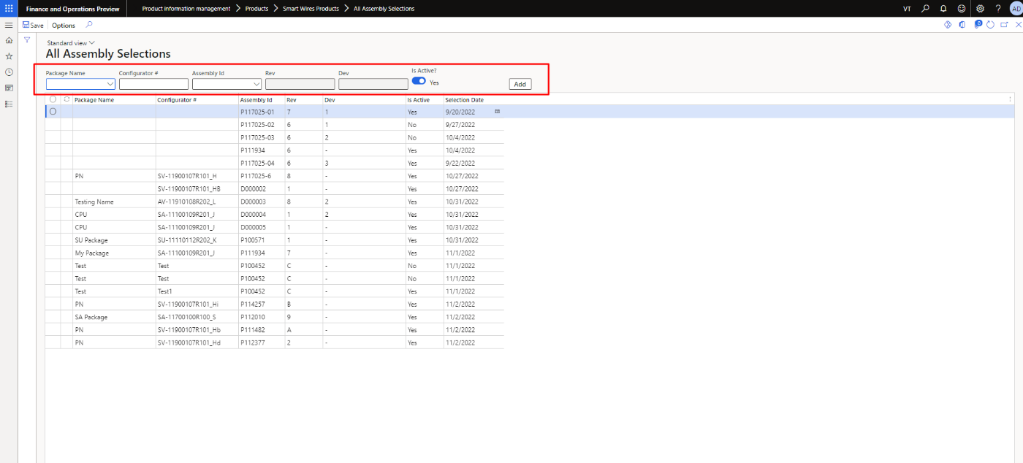

Figure 16. All Assemblies selection

The user can’t add the duplicate record in the list.

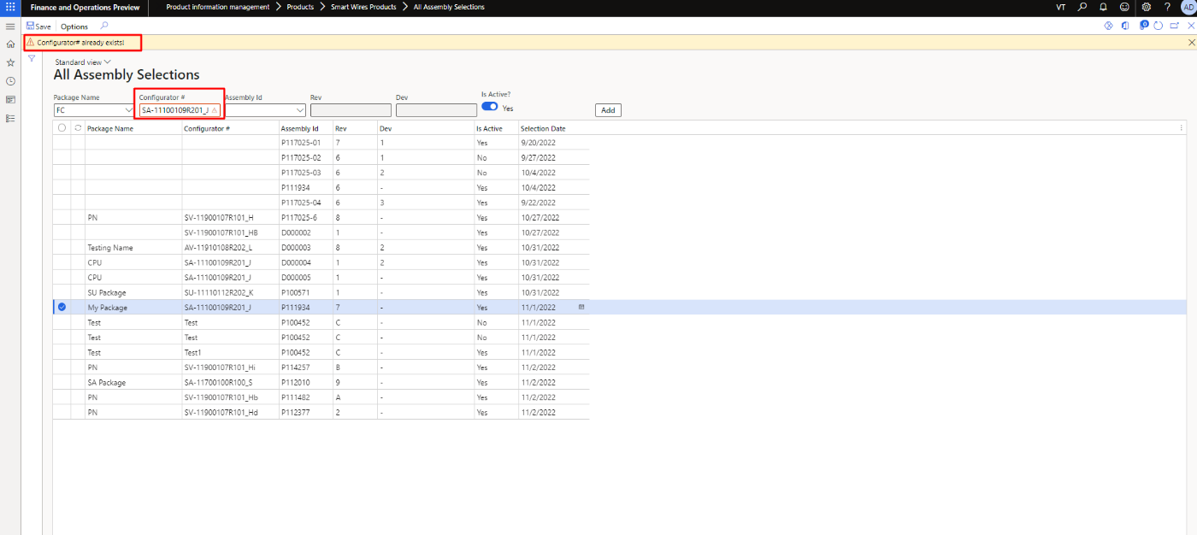

Figure 17. All Assemblies selections Configured Already Exist

The user will receive the success message after adding all the fields correctly.

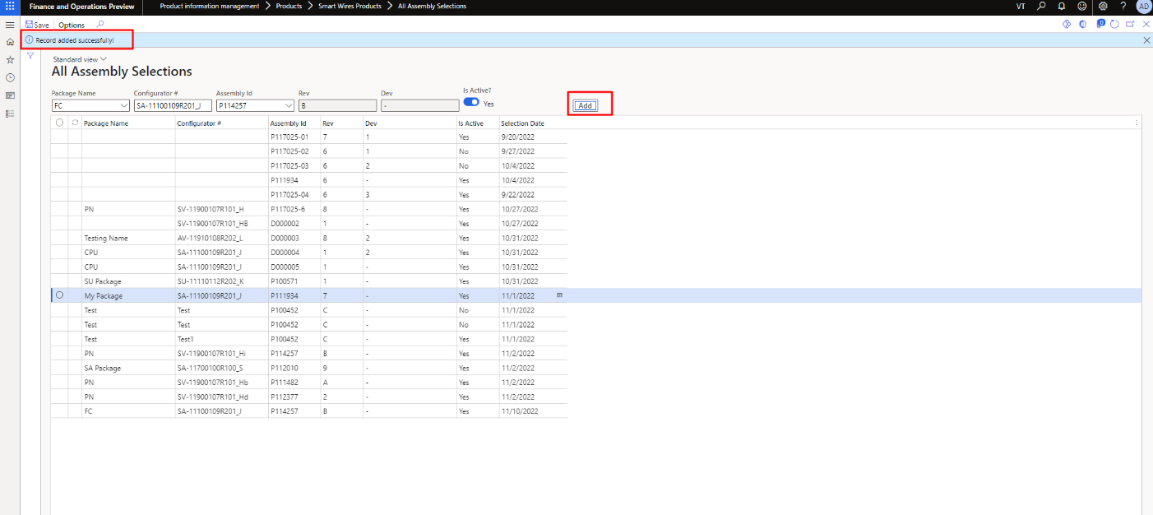

Figure 18 All Assemblies Selection Record Added Successfully

## All projects

The user can see and add new project in the list. The user needs to click on the New button to add the new project in the list. The user can also apply filter to view the specific project.

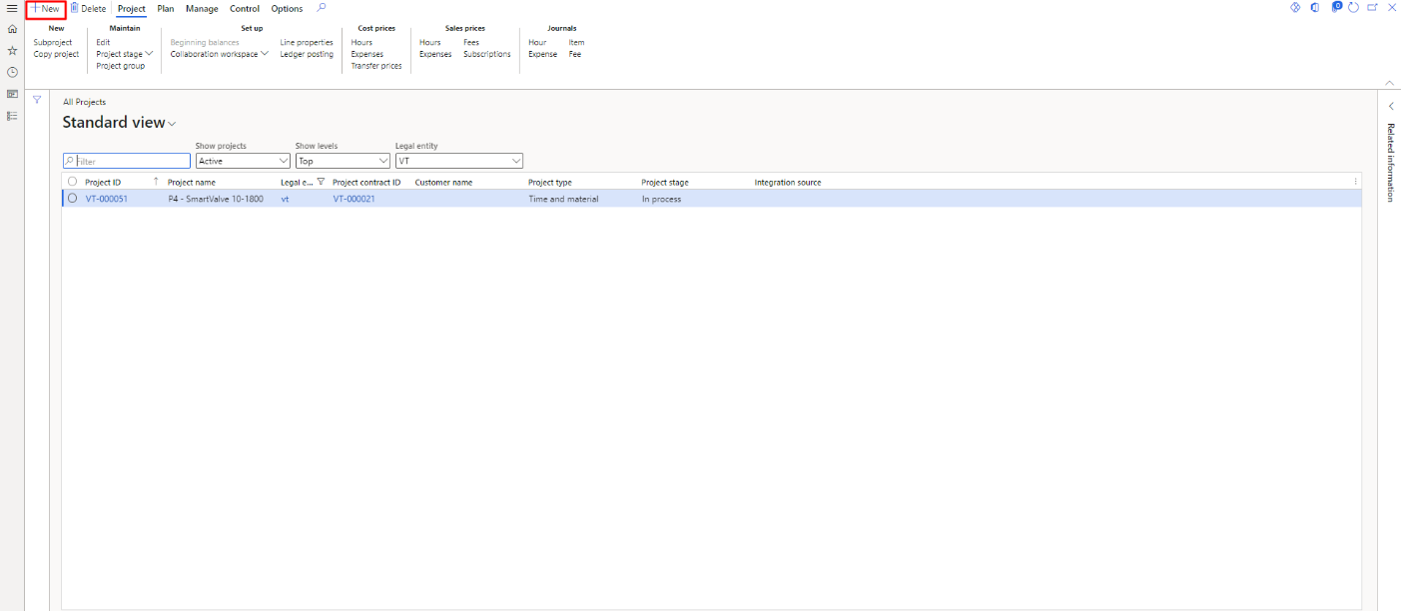

Figure 19. All Projects

The user will be able to see the new Project popup to add the new project. The user needs to fill the fields to add the new project. Project Name and project Contract ID are compulsory to add the new project.

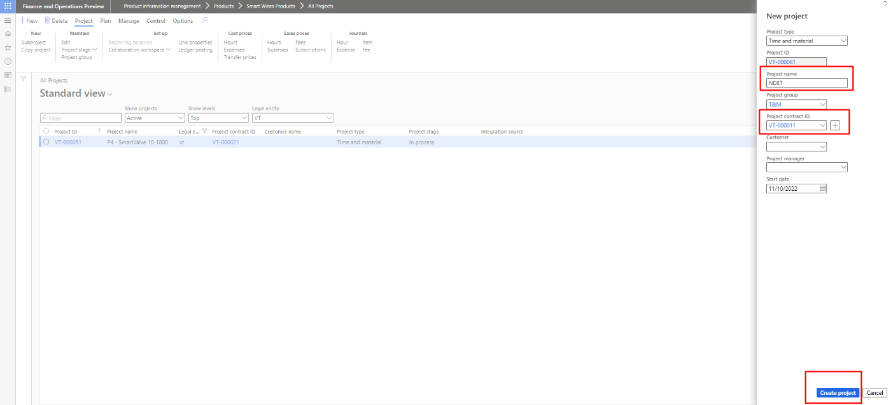

Figure 20 All projects Pop up

## All Customer

The user can see and add new customer in the list. The user needs to click on the New button to add the new customer in the list. The user can also apply filter to view the specific customer.

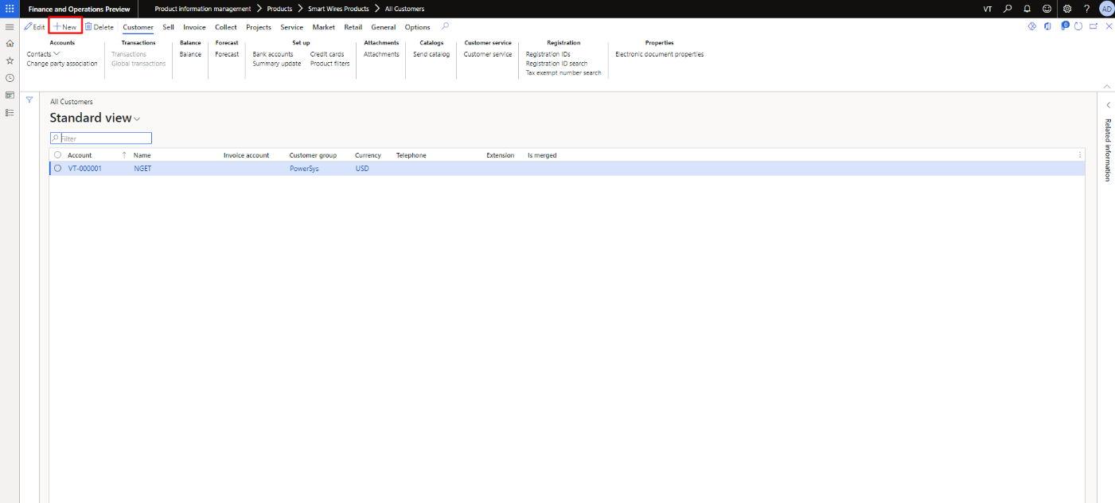

Figure 21 All Customer

The user will be able to see the new customer popup to add the new customer. The user needs to fill the fields to add the new customer. Customer Group field is compulsory to add the new project.

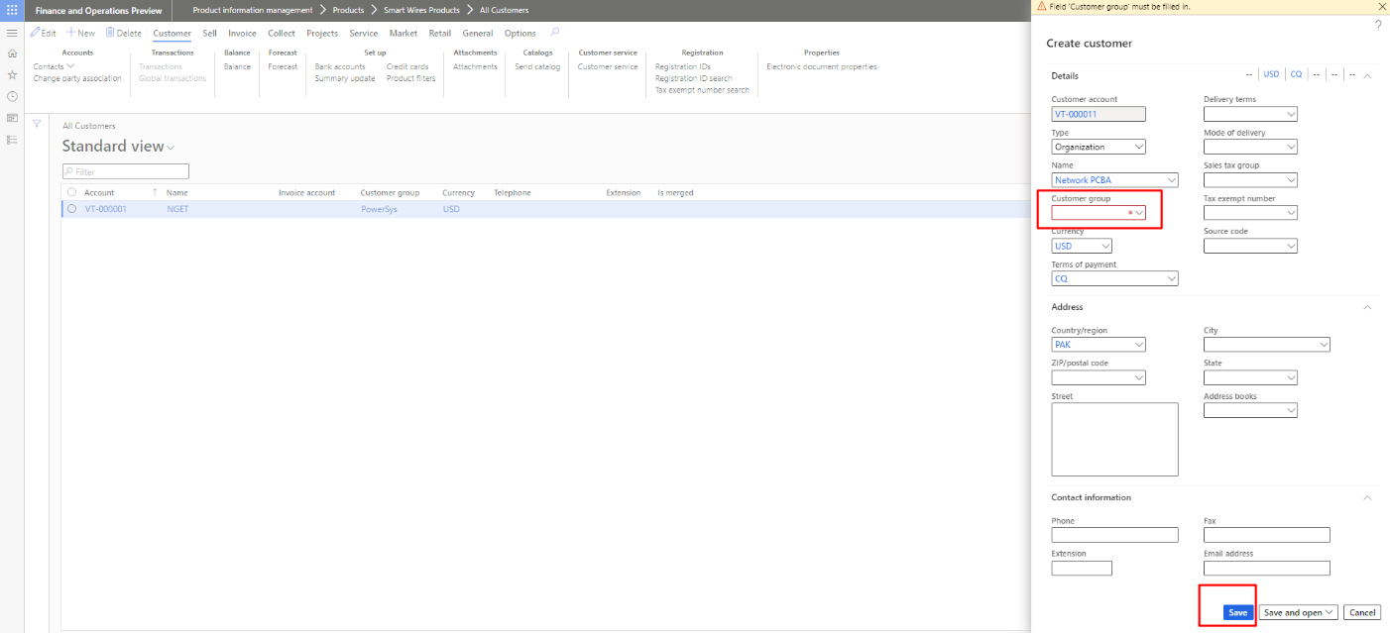

Figure 22 Custoemr Group field is Necessary

## All Customer Projects

The user can see and add new Customer projects in the list.

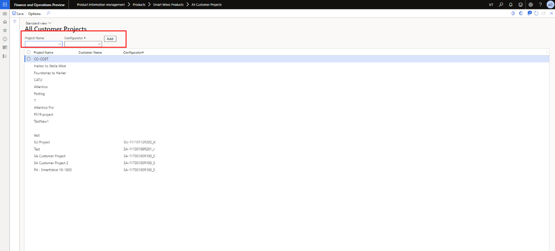

Figure 23 All Customers Projects

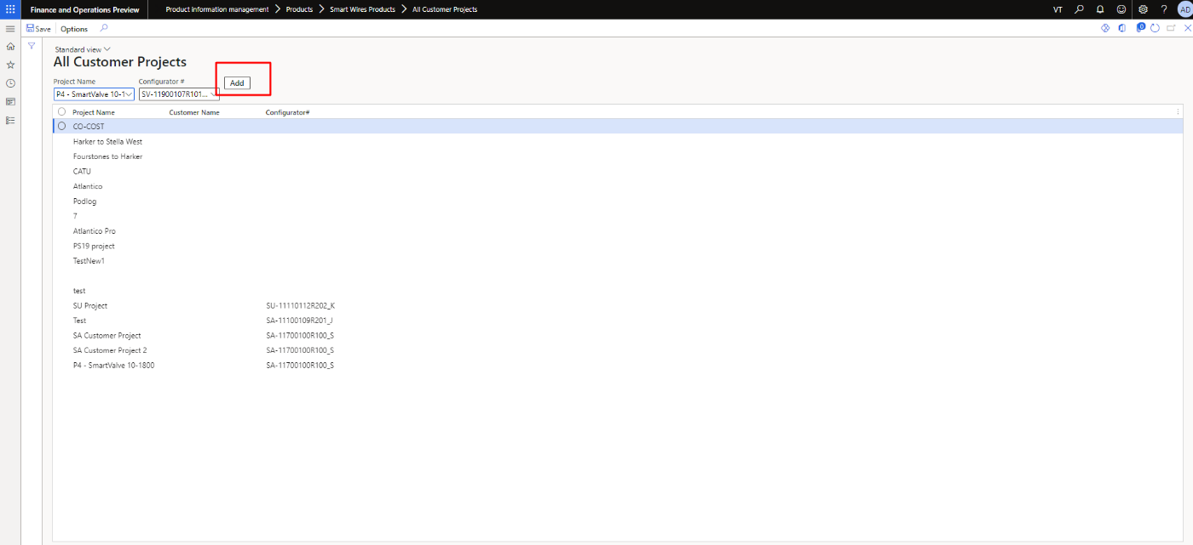

Figure 24 Press Add button to add Customer Project

The user can’t add the duplicate record in the list.

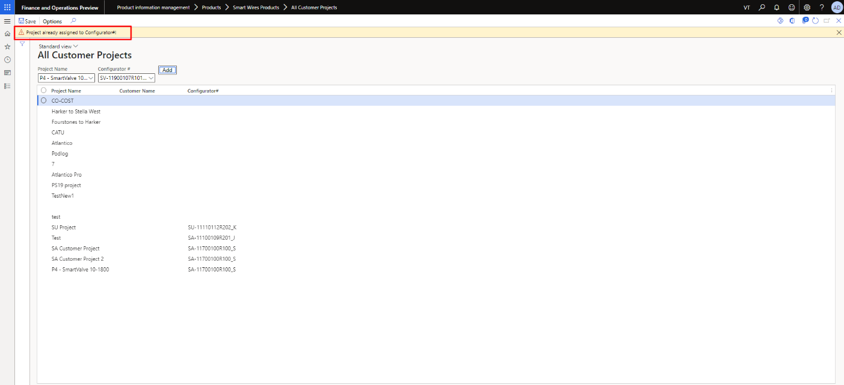

Figure 25 Duplicate Record Alert

## Import Project

In order to import project, select the modules option. Go to the Product Information Management and select Import project available under the Smart Wires Products.

Navigation: Product Information Management > Smart Wires Products > Import Project

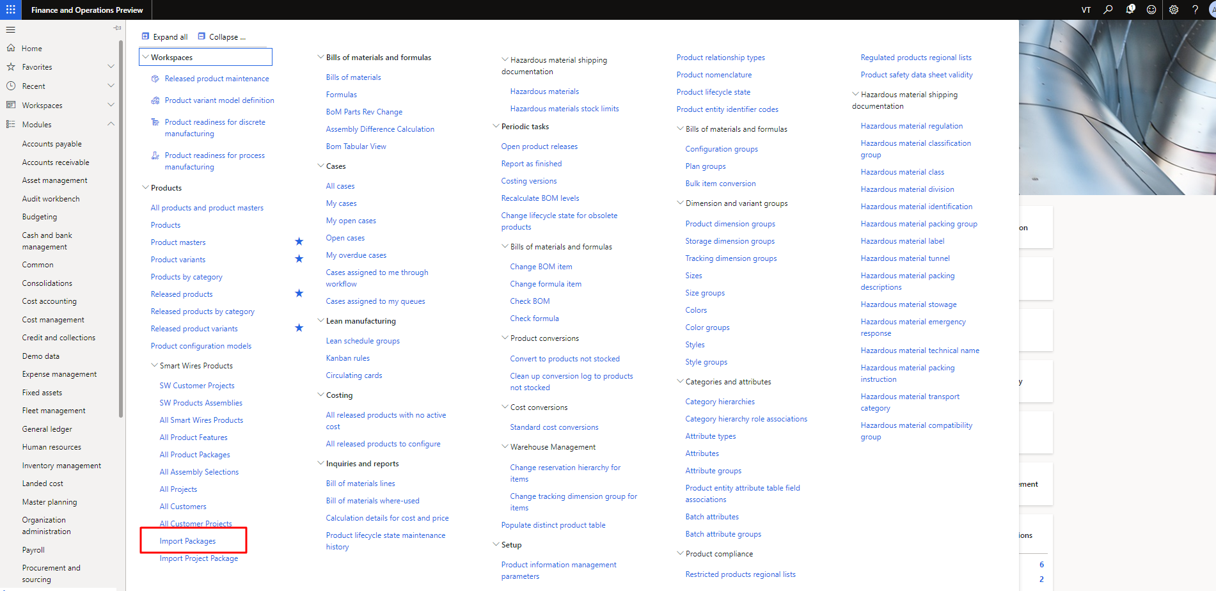

Figure 26 Import Project

The user needs to import the file after clicking on import package.

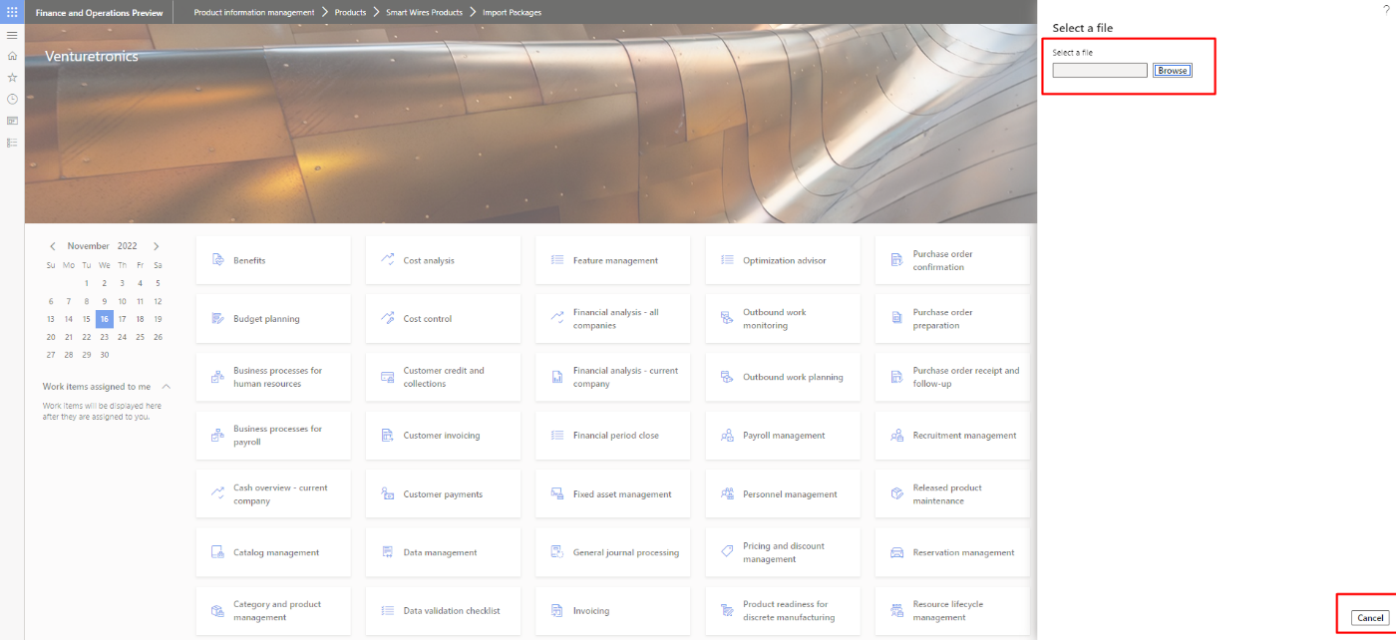

Figure 27 Browse file to import it

The user will receive the success message if the import is successfully done.

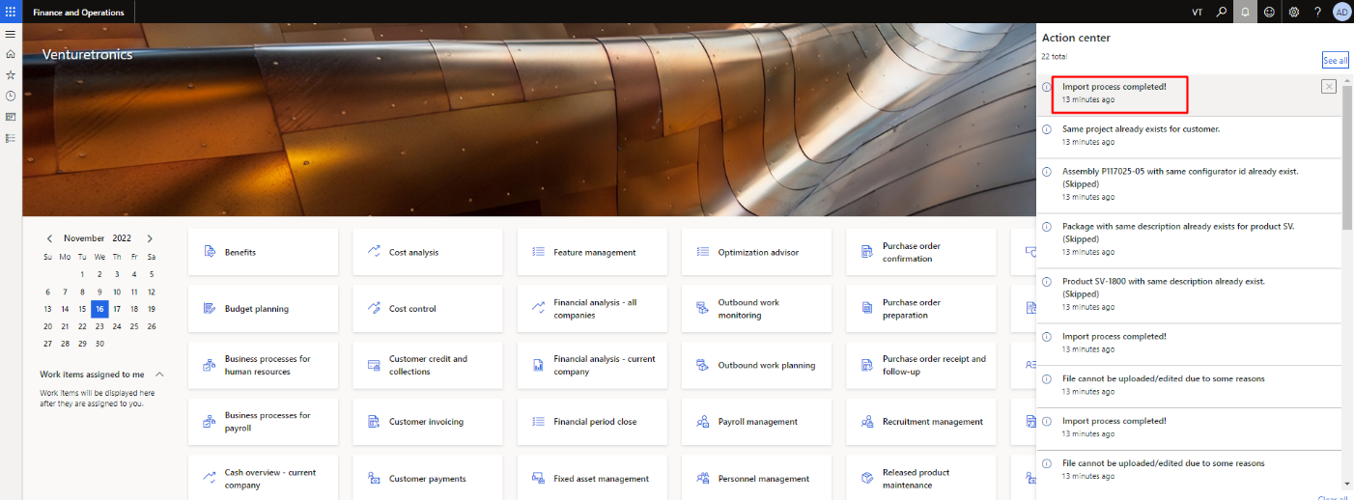

Figure 28 Message after importing the file

## Import Project Package

In order to import project package, select the modules option. Go to the Product Information Management and select Import project Package available under the Smart Wires Products.

Navigation: Product Information Management > Smart Wires Products > Import Project Package

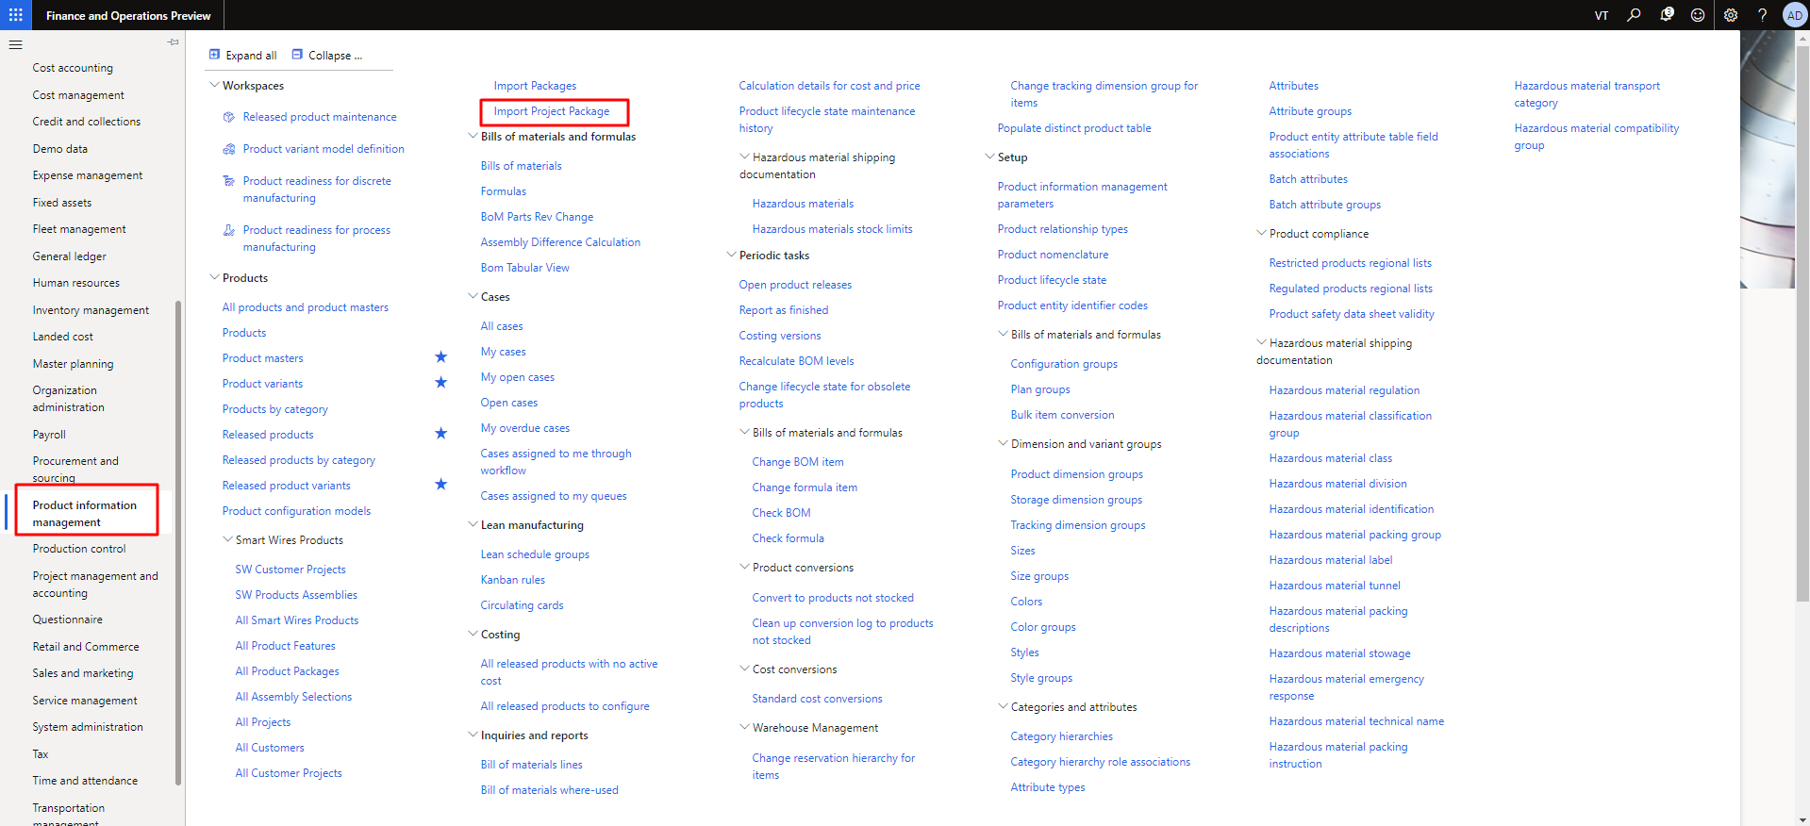

Figure 29 Import Project Package

The user needs to import the file after clicking on import package.

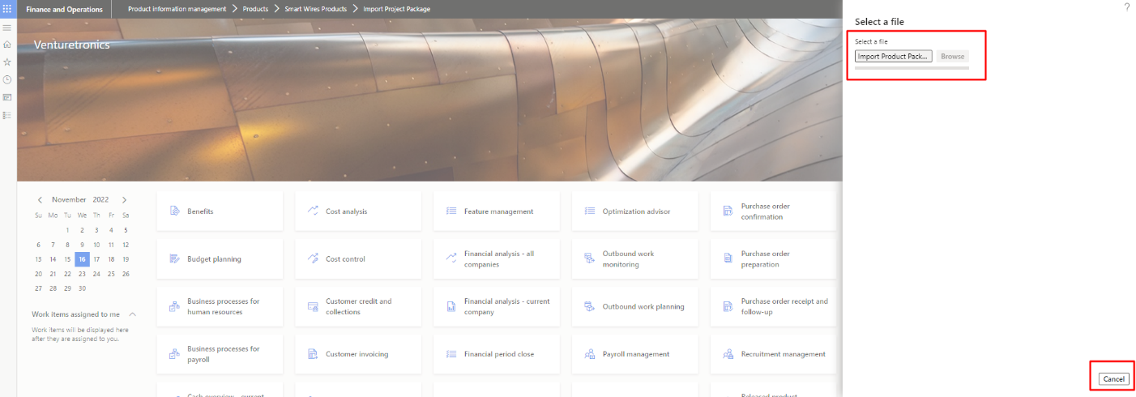

Figure 30 Browse file to import it

The user will receive the success message if the import is successfully done.  


Figure 31 Message after importing the file

# Work Instruction Document

In order to work on “**Work Instruction Document”**. Go to the Data management.

Navigation: Dashboard > Data Management.

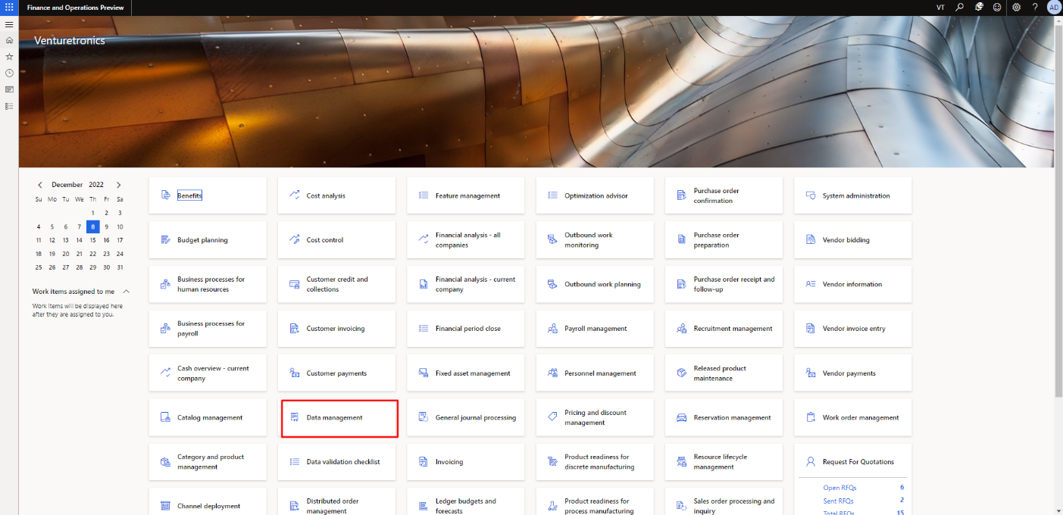

Figure 32 Data Management on Dashboard

The user needs to click on Import Work Instruction Documents to import the document.

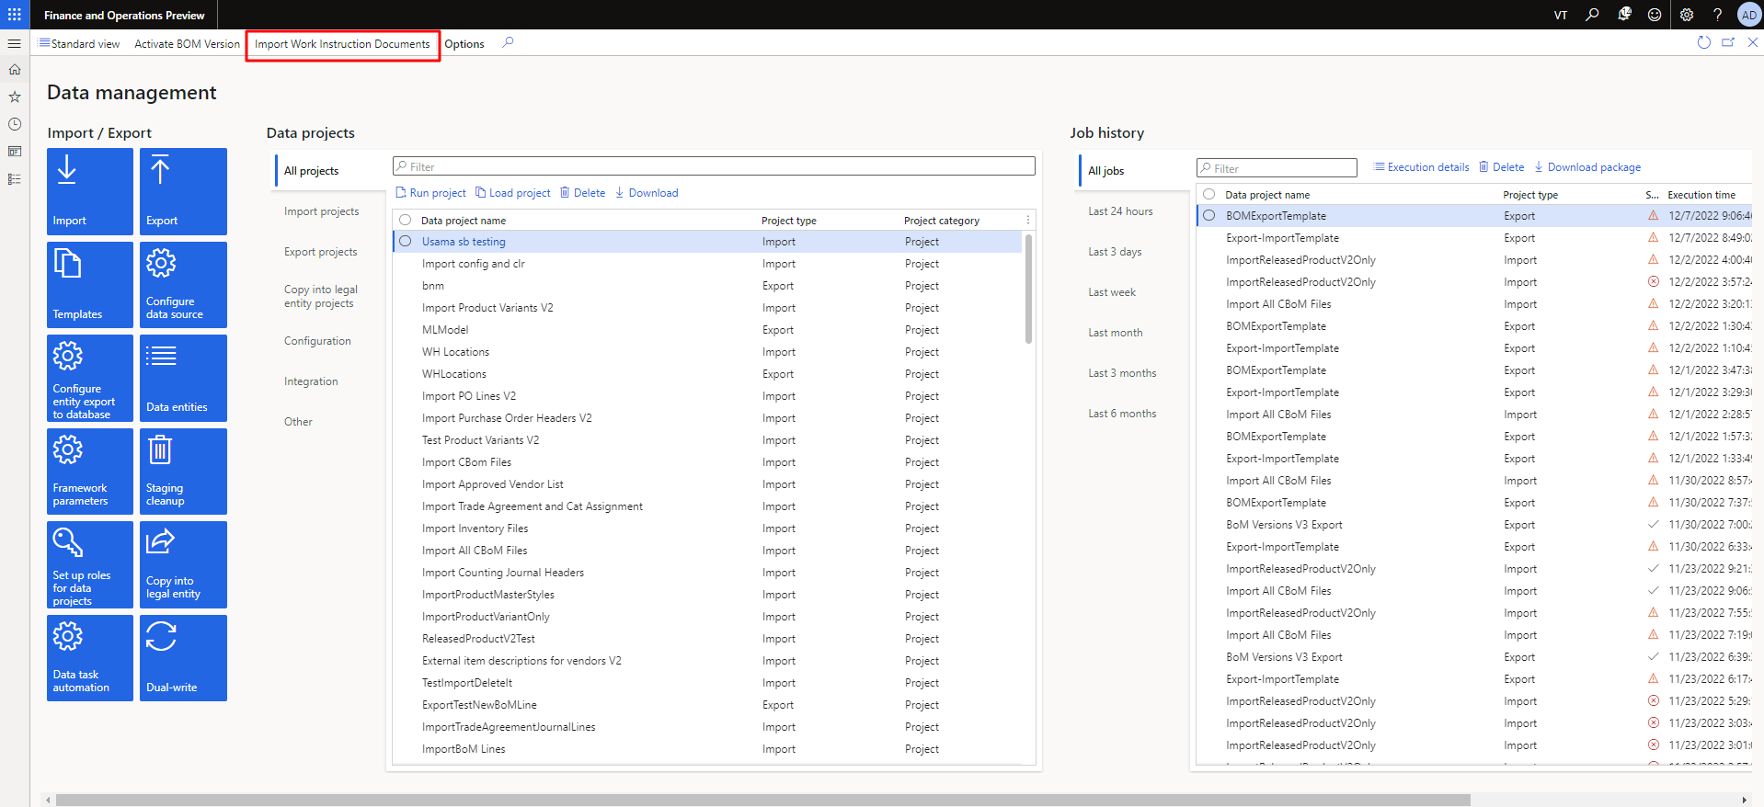

Figure 33 Click on Work Instruction Document

The user will receive the Pop-up alert to confirm the action to import the work instruction document. If the user clicks on “**yes**” then user will move to next action.

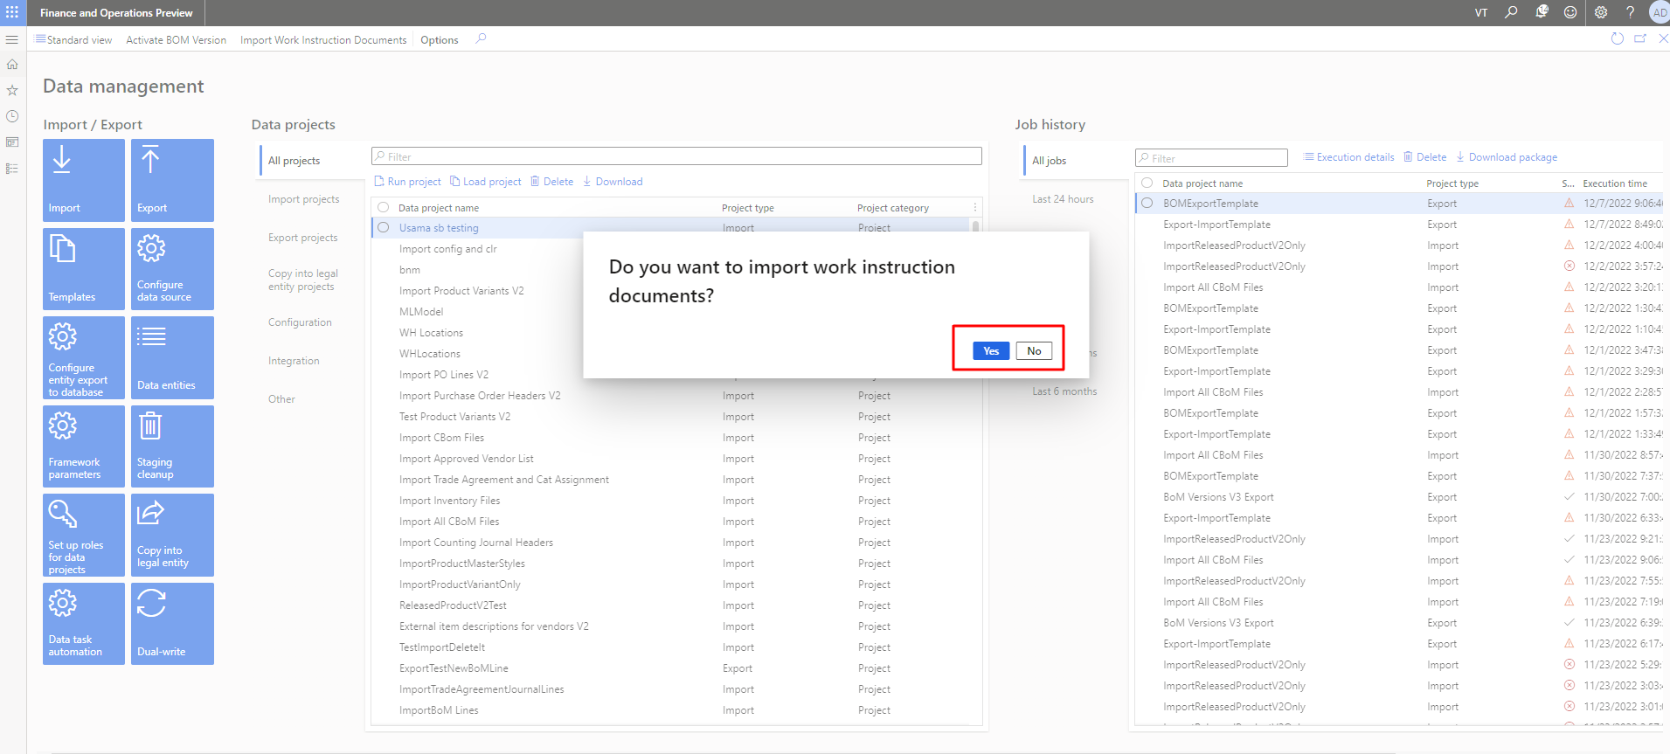

Figure 34 Confirmation popup to import the Work Instruction Document

As the user click on yes then user will be able to see the browse side bar to import the work instruction document. Work instruction file must be in the zip format.

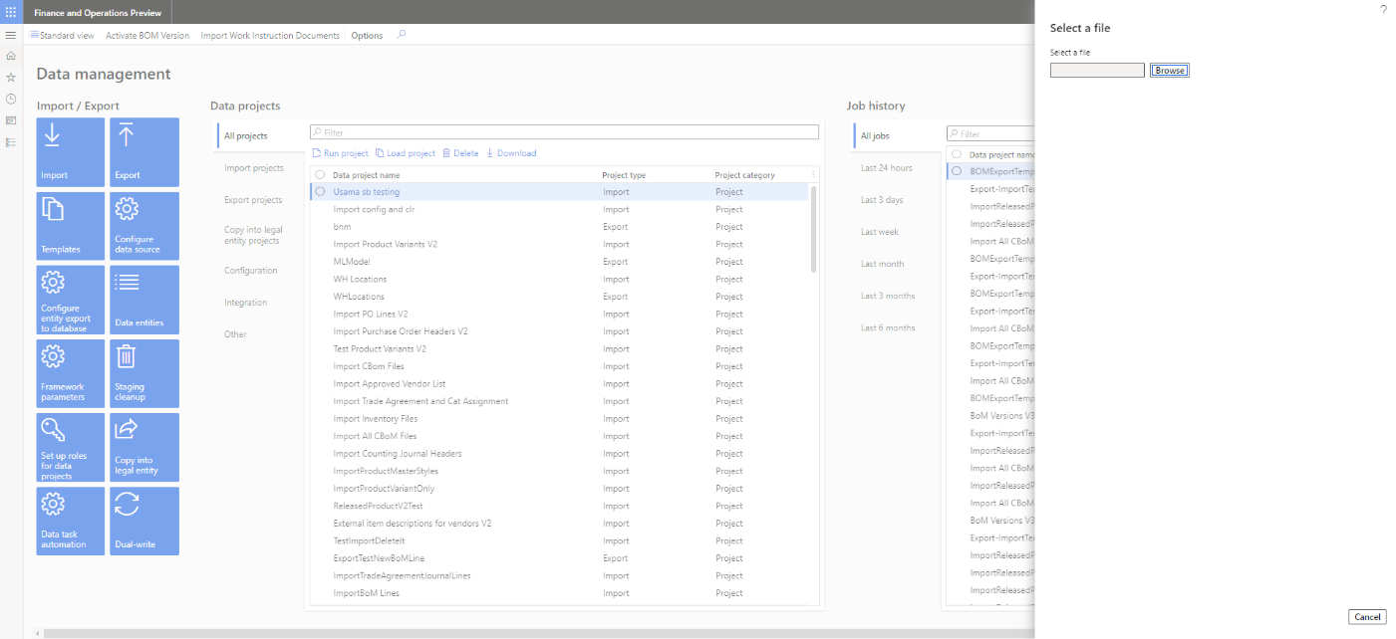

Figure 35 Upload the import Work Instruction Document

As the user upload the file successfully then system to the user to add the already exist items in the system.

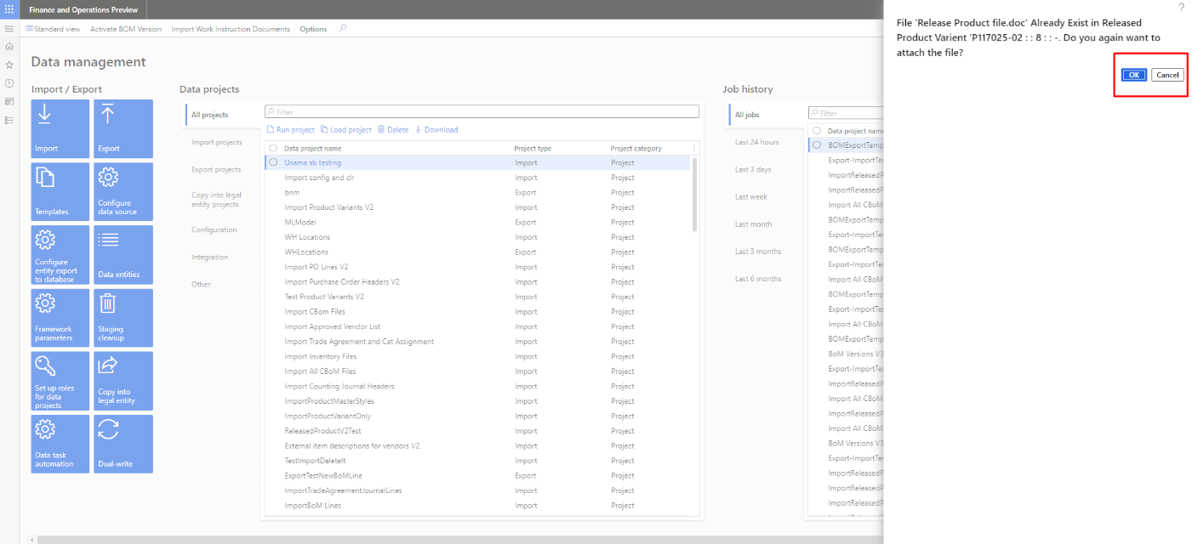

Figure 36 Confirmation Alert on Already Exist file i the item

As the file is uploaded success then user will be able to see the success message.

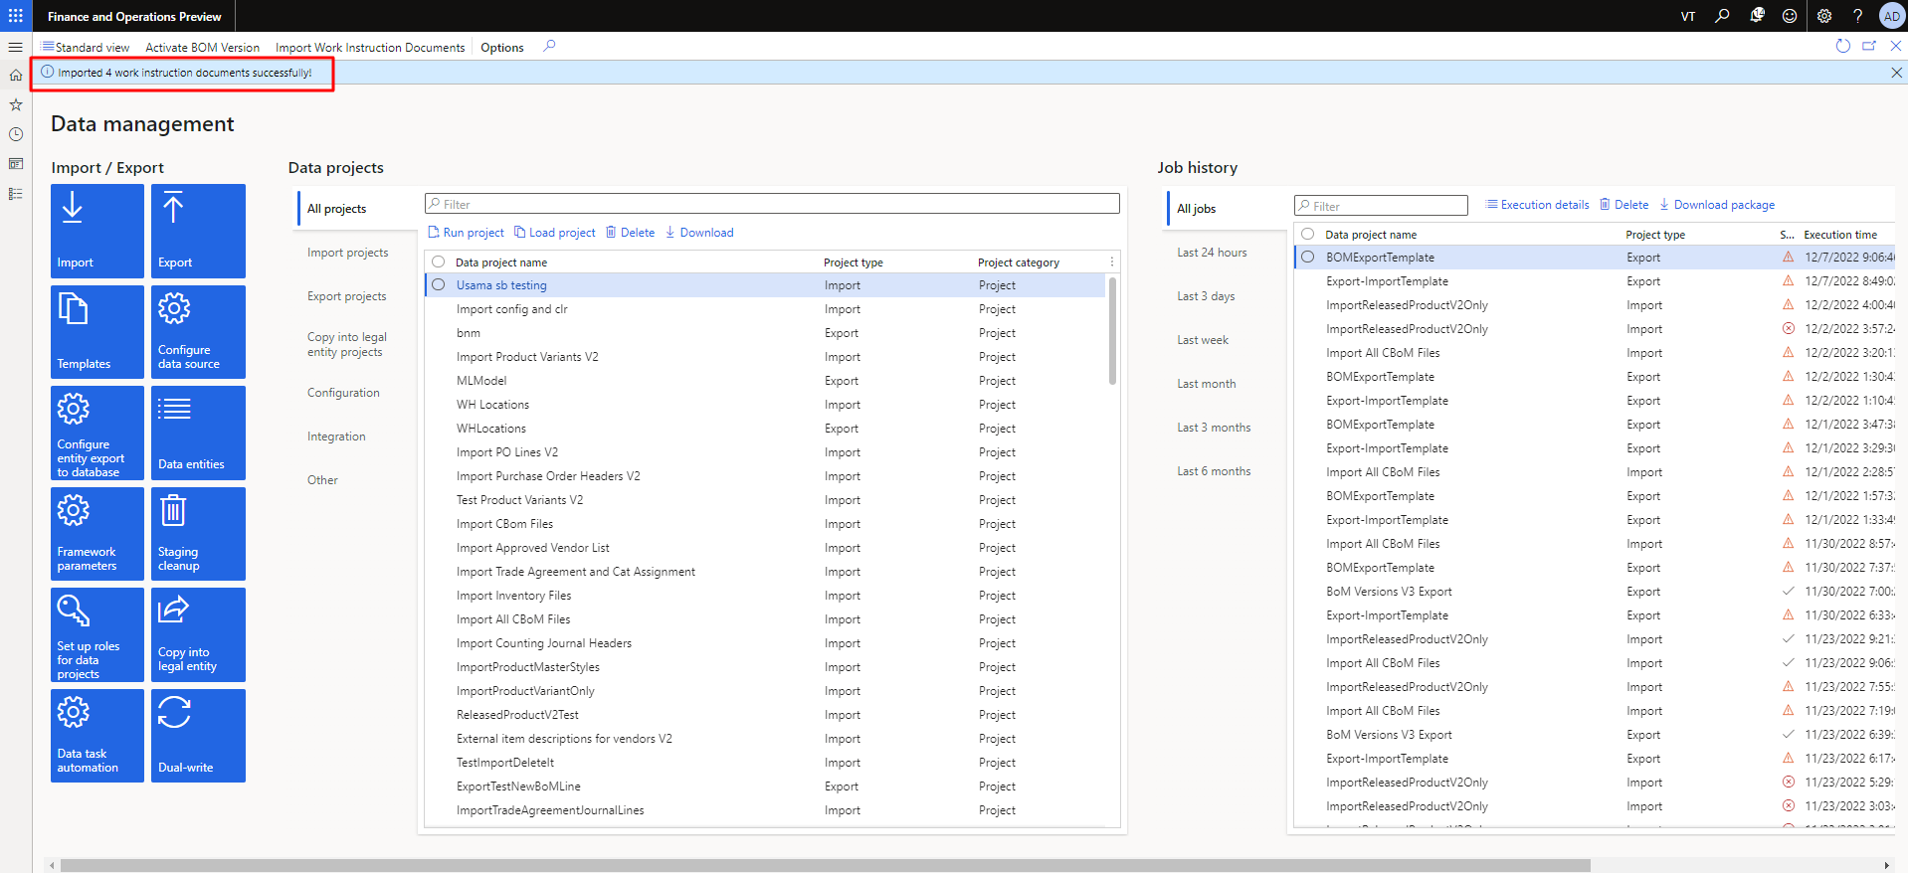

Figure 37 Success Message to after importing the Work instruction Document

The name of the imported zip file must same like data file in the zip file. File name must be same in the data excel file.

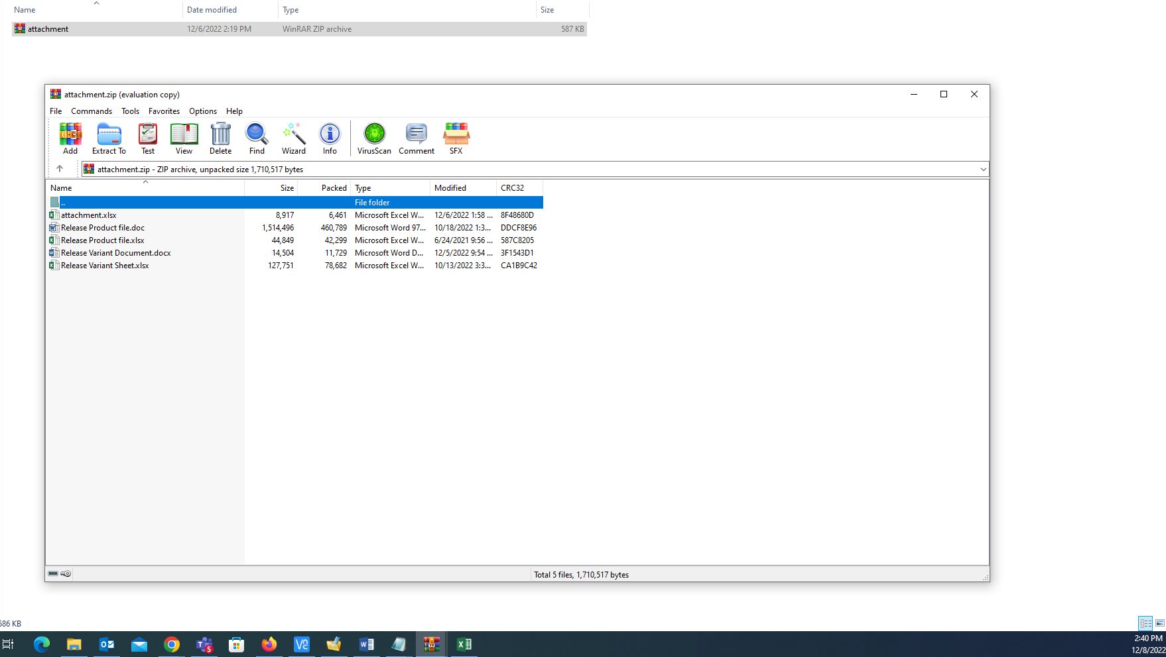

Figure 38 Zip file with included Documents

The user can see data sheet have same name as file in the zip.

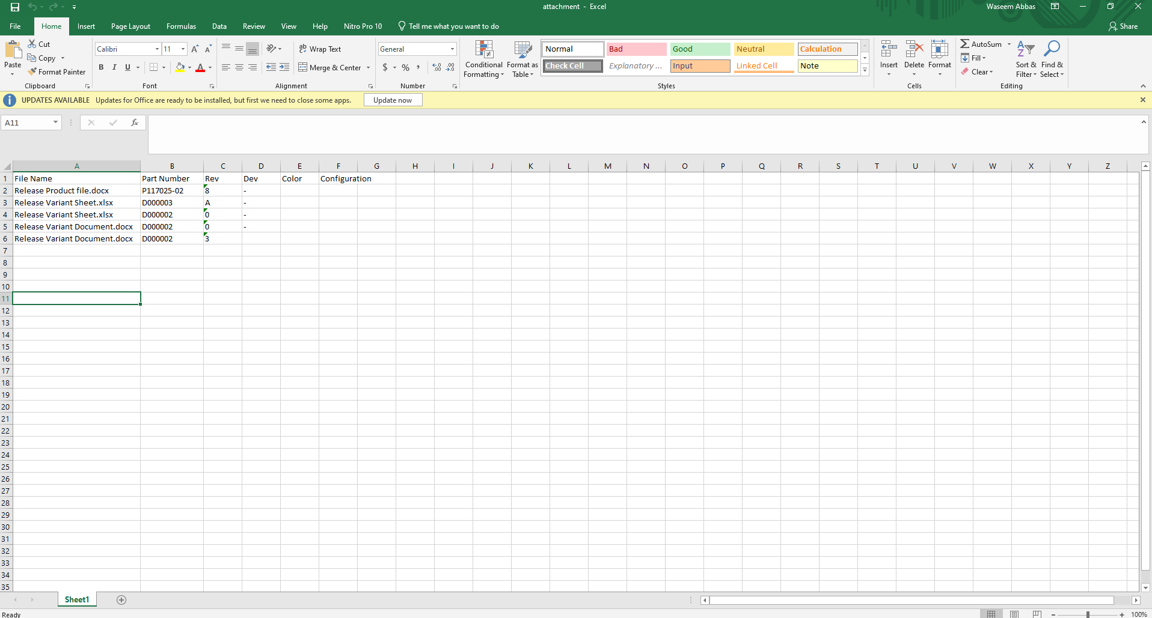

Figure 39 Data Sheet with the Same Name of file in the Zip

The user can see the imported file in the specific item number. The user needs to navigate:

Navigation: product Information and Management > Release Product Variant.

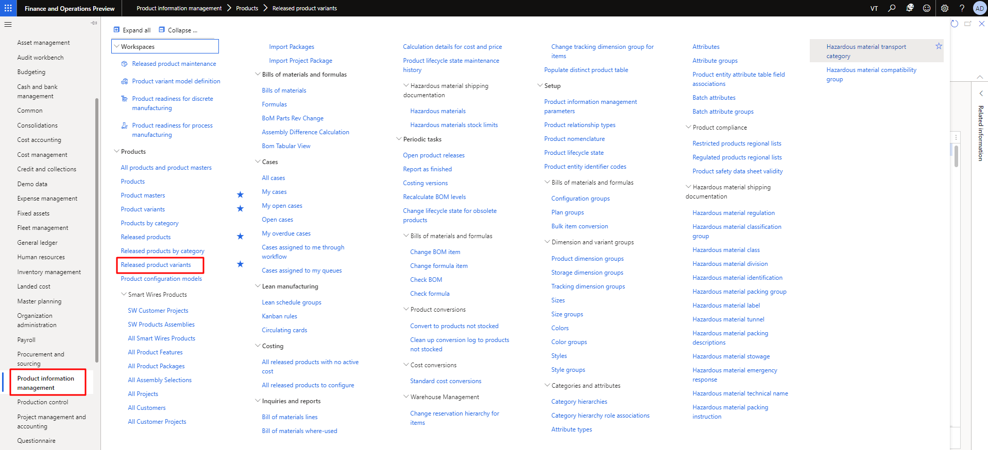

Figure 40 Release Product Variant to View the Products

The user needs to select the item and click on the I button after opening the specific item.

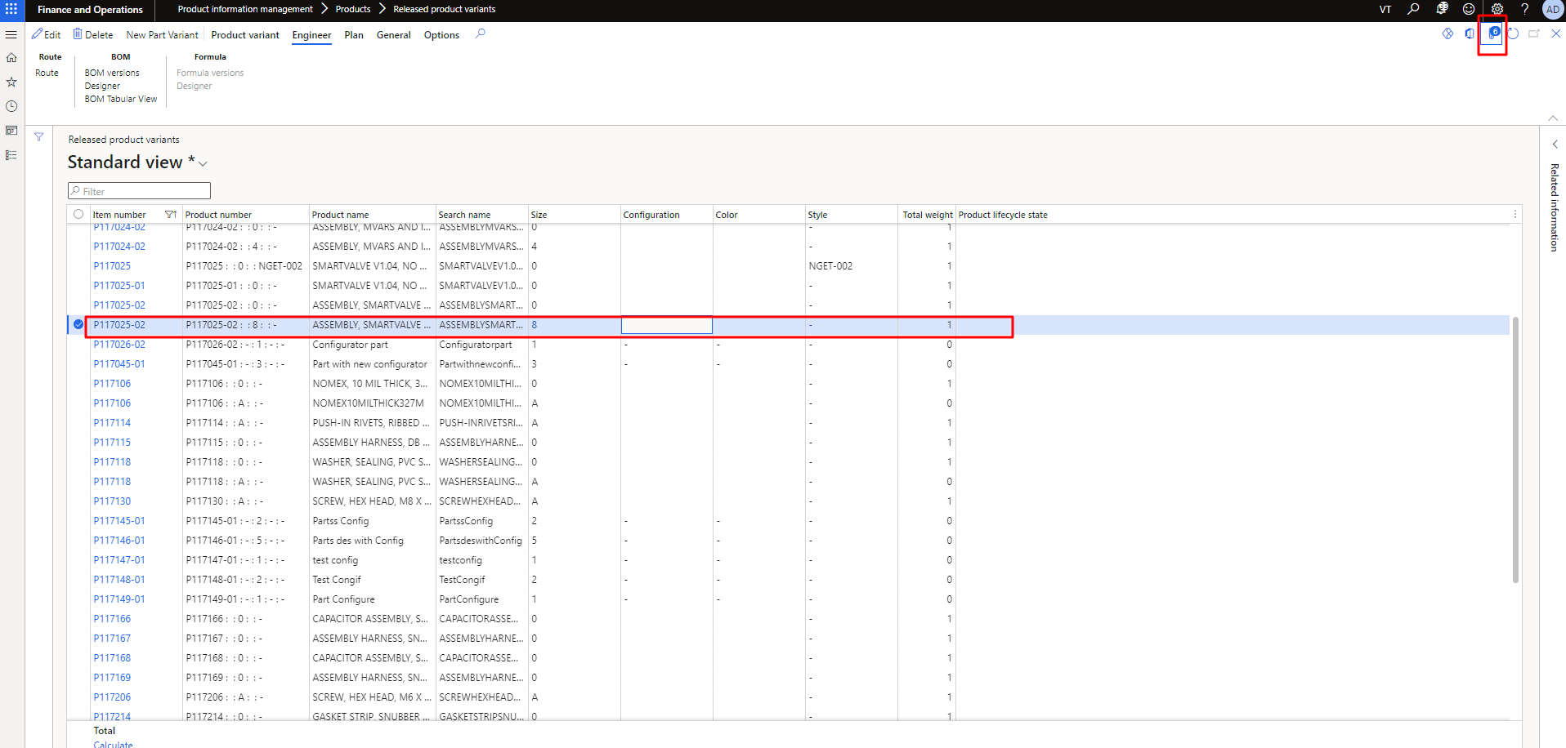

Figure 41 Select Item and Click on I After Selecting the Items

The user can see the see the imported file in the item. The user can also download them by clicking on open button.

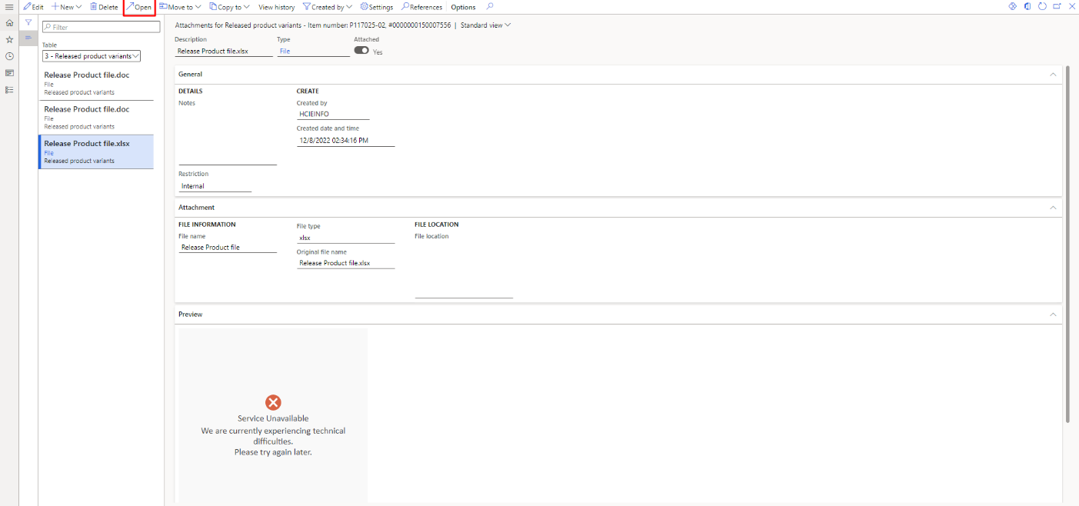

Figure 42 View and Download the selected File by clicking on open